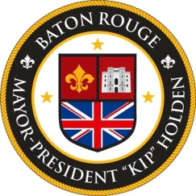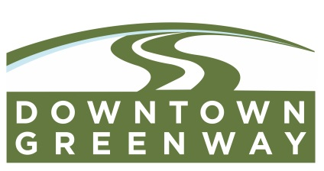

AGENDA
Downtown Greenway Groundbreaking
May 5, 2016 10:00 am
500 Block of North Boulevard
(In front of the Old Governor’s Mansion)

- Davis Rhorer – Opening/ Project Overview
Downtown Development District Executive Director

- Honorable Melvin “Kip” Holden
Mayor-President - City of Baton Rouge/Parish of East Baton Rouge
- Honorable Councilwoman Tara Wicker
District 10 - City of Baton Rouge/Parish of East Baton Rouge
- Mike Airhart
Capitol Area Finance Authority Executive Director

- Mark Martin
Bike Baton Rouge
- Davis Rhorer – Closing Remarks
Downtown Development District Executive Director
The celebratory groundbreaking will take place after the closing remarks.

